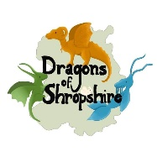
Dragons of Shropshire
Coronation Celebration Dragon Spotting Walk
1st – 14th May 2023

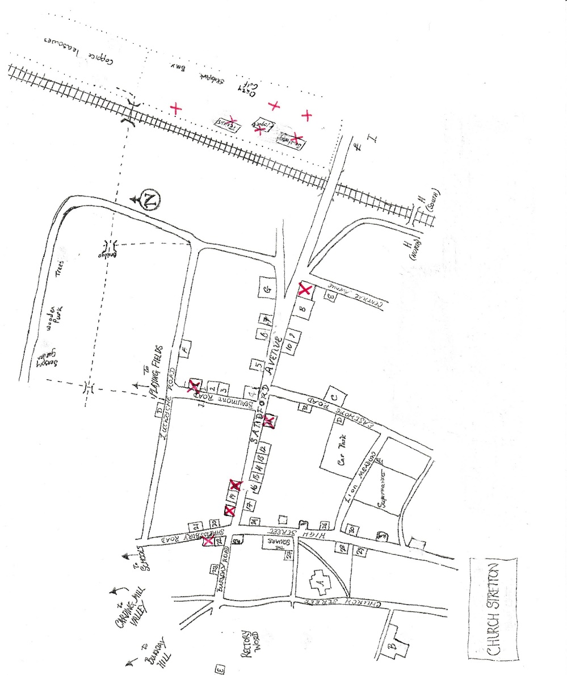
Dragons of Shropshire
Celebrate the Coronation of King Charles III with our Dragon Spotting Walk
There are 6 dragon sculptures & 6 dragon pictures to find.
When you spot a dragon, write down its colour.
Return your completed form by May 15th to Burway Books or shropshiredragonsopg@aol.com to be entered into our prize draw.
Dragon Picture | Dragon Colour
1
2
3
4
5
6
Dragon Sculpture
1
2
3
4
5
6

Name……………………………………………………………………………………………………(age…………….)
Contact Email or Phone number……………………………………………………………………………….
1st Prize is a Miniature Needlefelt Dragon Hatchling Sculpture
Details will only be kept long enough for prize draw to be completed and the winners notified.
1st Prize Winner will be contacted by Ceri Smith, the Dragons Archivist, for Dragon Hatchling colour preference. No cash prize alternative. Runners up prizes awarded at competition organisers discretion.

