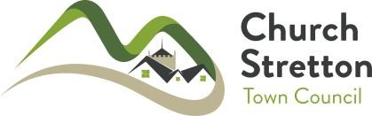

COMMUNITY SERVICE AWARD

NOMINATION FORM

This is a nomination for the following Community Service Award:

- The Long Service Award for adults working with young people Yes No

- The Long Service Award for adults working with adults Yes No

- The Community Group Award Yes No

- The Initiative Award Yes No

I nominate:

Name:

Address:

Email:

to receive a Community Service Award Certificate for services to the Town and people of Church Stretton as detailed below:-

I certify that the details given are correct, that I have not been influenced or canvassed in any way and that the person or community group nominated has no knowledge of the present application.

I understand that all matters relating to the nomination are confidential and that should the present nomination fail, it may be re-submitted after the expiry of twelve months.

PROPOSER:

Name: _____________________________ Signature:_________________________

Address: __________________________________________ Tel: ________________

SECONDER:

Name: _____________________________ Signature:_________________________

Address: ___________________________________________ Tel: _______________

Closing Date for Nominations: Friday March 31st 2023

Please return to: The Town Clerk, Church Stretton Town Council, 60 High Street,
Church Stretton, SY6 6BY
Tel: 01694 722113 Email: townclerk@churchstretton-tc.gov.uk

